T

CANDIDATE
NAME
CIVICS  GROUP |  |  | /

CHEMISTRY 8872/02
Paper 2 28th September 2009
2 hours

Candidates answer Section A on the Question Paper.

Additional Materials: Answer Paper
Data Booklet

READ THESE INSTRUCTIONS FIRST

Write your Civics Group number and candidate name on all the work you hand in.
Write in dark blue or black pen.
You may use a soft pencil for any diagrams, graphs or rough working.
Do not use staples, paper clips, highlighters, glue or correction fluid.

Section A
Answer all questions.
For Examiner’s Use
Paper 1 |  |  | /30
Paper 2 | A1 |  | /9
 | A2 |  | /12
 | A3 |  | /12
 | A4 |  | /7
 | B |  | /20
 | B |  | /20
Total |  |  | /110
Percentage |  |  | %

Section B
Answer two questions on separate answer paper.

At the end of the examination, fasten all your work securely together.
The number of marks is given in brackets [ ] at the end of each question or part question.


TEMASEK JUNIOR COLLEGE
Preliminary Examinations
Higher 1

This document consists of 14 printed pages.
Section A

Answer all questions in this section in the spaces provided.

1 | (a) | The first six ionisation energies of three successive elements in a Periodic Table are given below:
   | Ionisation Energy in kJ mol⁻¹
  Element | 1st | 2nd | 3rd | 4th | 5th | 6th
  A | 786 | 1580 | 3230 | 4360 | 16100 | 19800
  B | 1060 | 1900 | 2920 | 4960 | 6270 | 21300
  C | 1000 | 2260 | 3390 | 4540 | 7000 | 8500
 |  | (i) | State and explain the Group of the Periodic Table which element B belongs to.
 |  |  | ...........................................................................................................................................
...........................................................................................................................................

...........................................................................................................................................

 |  | (ii) | Explain why the first ionisation energy of B is higher than each of A and C.
 |  |  | ...........................................................................................................................................
 |  |  | ...........................................................................................................................................
 |  |  | ...........................................................................................................................................
 |  |  | ...........................................................................................................................................
...........................................................................................................................................

...........................................................................................................................................

 |  |  | [5]
 | (b) | - Write a balanced equation for the preparation of 1-bromopentane from pentan-1-ol.  ...........................................................................................................................................
 |  | (ii) |  | If this preparation gives a yield of 60%, what mass of pentan-1-ol is required to produce 15.0 g of 1-bromopentane?
 |  |  | [4]
 |  |  | [Total: 9]
2 | (a) | In the laboratory, the presence of SO₂ can be confirmed using an acidified solution of K₂Cr₂O₇. The SO₂ is oxidised to form SO₄²⁻ by K₂Cr₂O_{7.}
 |  | (i) | State the oxidation state of S in SO₂ and SO₄²⁻ and write an ion-electron half equation for the oxidation of SO₂ to SO₄²⁻.
 |  |  | .........................................................................................................................................
 |  |  | ...........................................................................................................................................
 |  |  | ...........................................................................................................................................
 |  | (ii) | Write a balanced equation for the above reaction.
 |  |  | ...........................................................................................................................................
 |  |  | [3]
 | (b) | 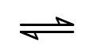  SO₂ can be converted into SO₃ and it involves the following equilibrium reaction:  2SO₂(g) + O₂(g) 2SO₃(g) ΔH = -196 kJ mol⁻¹
- When 1.5 mol of SO₂ is mixed with 0.5 mol of O₂ in 650 cm³ closed vessel at 450 ºC, it was found that 94 % of O₂ reacted. Calculate the equilibrium concentration of SO₂, O₂ and SO₃.

- Hence calculate K_{c} for the reaction, stating its units.

[5]

- Explain the effect on the position of equilibrium and K_{c} value when the total volume of the system was increased.
…………………………………………………………………………………………….
…………………………………………………………………………………………….
…………………………………………………………………………………………….
…………………………………………………………………………………………….
…………………………………………………………………………………………….
…………………………………………………………………………………………….

- Explain why a temperature of 450 ºC was chosen as opposed to using much higher or lower temperatures.
…………………………………………………………………………………………….
…………………………………………………………………………………………….
…………………………………………………………………………………………….
…………………………………………………………………………………………….
…………………………………………………………………………………………….
…………………………………………………………………………………………….
[4]
 |  |  | [Total: 12]
3 | (a) | For the reaction scheme below, give the reagents and conditions for Step I and Step II in the space provided, and draw the structural formula of Compound A and B in the boxes provided.  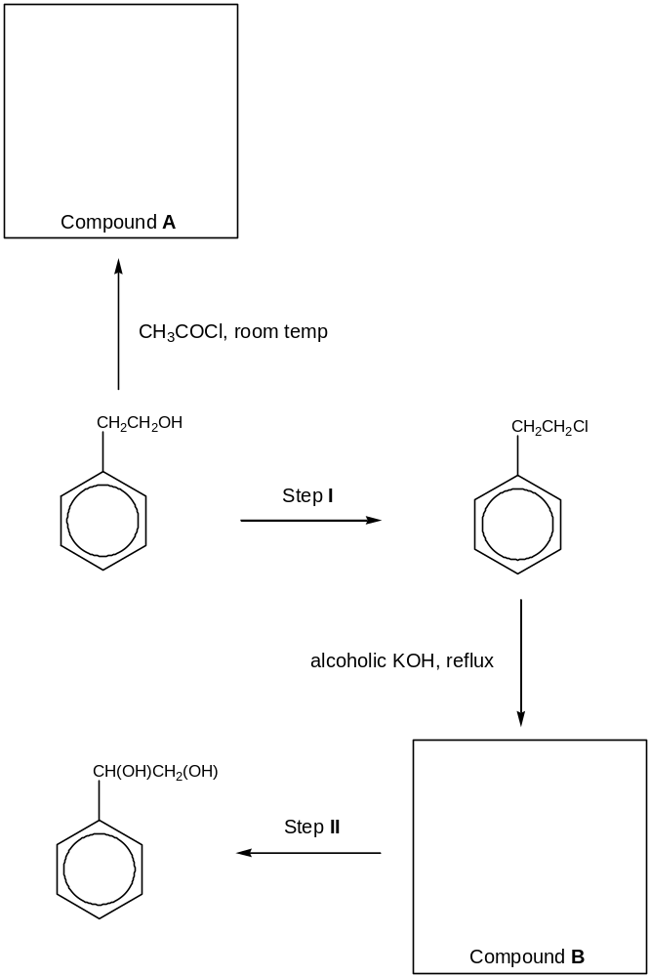  Step I:  Reagents: …………………...…………………………………………………………………….  Conditions: …………………...…………………………………………………………...………  Step II:  Reagents: …………………...…………………………………………………………………….  Conditions: …………………...…..……………………………………………………………….  [6]
 | (b) | Compound A undergoes hydrolysis with dilute H₂SO₄(aq) under reflux to give two compounds. Give the structural formula of the two compounds formed and describe a chemical test to distinguish between the two compounds.
...........................................................................................................................................

…………………………………………………………………………………………………......

……………………………………………………………………………………………………...

……………………………………………………………………………………………………...

[3]

 | (c) |  | Explain why propane (Mr = 44), is a gas as under standard conditions and is insoluble in water whereas ethanol (Mr = 46) is a liquid and is soluble in water.
 |  |  | ...........................................................................................................................................
 |  |  | ...........................................................................................................................................
 |  |  | ...........................................................................................................................................
 |  |  | ...........................................................................................................................................
 |  |  | ...........................................................................................................................................
 |  |  | ...........................................................................................................................................
 |  |  | ...........................................................................................................................................
[3]

[Total: 12]
4 | (a) | This question is about chlorine and its compounds.  The melting point of POCl₃ is 1.25 ºC whereas the melting point of PCl₅ is 166.8 ºC.
 |  | (i) | Name and draw diagrams to illustrate the shapes of POCl₃ and PCl₅.
 |  | (ii) | Explain, in terms of structure and bonding, why PCl₅ has a higher melting point.
 |  |  | …………….........................................................................................................................
 |  |  | ………………......................................................................................................................
 |  |  | ………….............................................................................................................................
………................................................................................................................................

………………......................................................................................................................

...........................................................................................................................................
 |  |  | [4]
 | (b) | Suggest a synthetic route for the synthesis of:  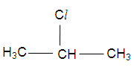  from  2-chloropropane  propan-1-ol
[3]

[Total: 7]

Section B

Answer two of the three questions in this section on separate paper.

5 | Ethanoic acid, CH₃COOH reacts with sodium hydroxide in a neutralisation reaction.
 | (a) | In a titration experiment, 20 cm³ of 0.250 mol dm⁻³ of CH₃COOH (pH = 2.67) was titrated against 0.1 mol dm⁻³ NaOH.
 |  | (i) |  |  | Define the term pH.
 |  | (ii) |  |  | Calculate pH of the NaOH solution.
 |  | (iii) |  |  | Write a balanced equation for the above neutralisation reaction.
 |  | (iv) |  |  | Find the volume of NaOH required for complete neutralisation of CH₃COOH.
 |  | (v) |  |  | Hence find the concentration of the salt formed at equivalence point.
 |  | (vi) |  |  | Suggest a suitable indicator, with reasoning, for the titration reaction. State the colour change when the end-point was reached.
 |  | (vii) |  |  | An acidic buffer solution is formed when 10 cm³ of NaOH was added to the CH₃COOH solution.
 |  |  |  |  | - Explain what is meant by the term buffer solution.
 |  |  |  |  | - Explain how such a buffer solution works.
 |  | (viii) |  |  | Hydrochloric acid also undergoes neutralisation reaction with sodium hydroxide. It was found that the concentration of CH₃COOH is the same as that of HCl but their pH values are different. Explain why.
 |  |  |  |  | [14]
 | (b) | In another experiment, an experiment to determine the enthalpy change of neutralisation between aqueous CH₃COOH and aqueous NaOH was conducted.
 |  | (i) |  |  | Define standard enthalpy change of neutralisation.
 |  | (ii) |  |  | 40 cm³ of 0.875 mol dm⁻³ aqueous CH₃COOH was added to 40 cm³ of 1.5 mol dm⁻³ aqueous NaOH in a polystyrene beaker. The initial temperature of both solutions was 25.8 ºC. After stirring and accounting for heat loss, the highest temperature reached was 31.3 ºC. Calculate the enthalpy change of neutralisation given that the heat capacity of the solution is 4.18 J g⁻¹ K⁻¹ and the densities of the solutions assumed to be 1 g cm⁻³.
 |  | (iii) |  |  | It was found that the enthalpy change of neutralisation between aqueous HCl and aqueous NaOH is - 57.3 kJ mol⁻¹. Comment on the difference in values of the enthalpy changes calculated in (b)(ii) and the one stated here.  [6]
 |  |  | [Total: 20]
6 | (a) | Compound X reacts with hydrogen as shown by the equation below.  CH₂=C(CH₃)CO₂H (l) + H₂ (g) → CH₃CH(CH₃)CO₂H (l)  Compound X  State the reagents and conditions for the above reaction. Name the mechanism involved.  [2]
 | (b) | Compound X undergoes hydration and the rate of hydration was followed by measuring the change in concentration of Compound X with time. Two experiments were carried starting with different concentrations of H⁺. The following results were obtained.
  Time/  minutes | Expt 1, with [H⁺] = 0.10 mol dm⁻³ | Expt 2, with [H⁺] = 0.05 mol dm⁻³
  Time/  minutes | [Compound X]/ mol dm⁻³ | [Compound X]/ mol dm⁻³
  0 | 0.0050 | 0.0050
  15 | 0.0040 | 0.0045
  30 | 0.0032 | 0.0040
  45 | 0.0026 | 0.0036
  60 | 0.0021 | 0.0032
  75 | 0.0017 | 0.0029
  90 | 0.0014 | 0.0026
 |  | (i) |  | Using the same axes, plot graphs of [Compound X] against time for the two experiments.
 |  | (ii) |  | Use your graphs to determine the order of reaction with respect to [H⁺] and to [Compound X], showing your working clearly. Hence give the rate equation for the reaction.
 |  | (iii) |  | Calculate the initial rate from experiment 1, and use it, together with your rate equation, to calculate the rate constant for the reaction, including units.
 |  |  |  | [7]
 | (c) | Explain how the increase in temperature affects the rate of the reaction, by means of a Maxwell Boltzmann diagram. [4]
 | (d) | 20 cm³ of Compound X was reacted with 30 cm³ of 0.1 mol dm⁻³ sodium hydroxide. Subsequently this solution required 20 cm³ of 0.05 mol dm⁻³ hydrochloric acid for neutralization. Calculate the concentration of Compound X.  [3]
 | (e) | Beryllium has a diagonal relationship with aluminium in the Periodic Table. Explain why beryllium chloride is more volatile than magnesium chloride.  [4]
 |  |  | [Total: 20]
7 | (a) | Sodium, silicon, and phosphorus are three elements from period 3 of the Periodic Table. Describe and explain the differences in electrical conductivity of these three elements.  [3]
 | (b) | Sodium, silicon, and phosphorus combine directly with chlorine to form chlorides.
 |  | (i) |  | State the formulae of the chlorides of the three elements.
 |  | (ii) |  | Describe the reactions, if any, of these chlorides with water.  Write balanced equations where appropriate.
 |  | (iii) |  | Draw a “dot-and-cross” diagram to illustrate the bonding in the chloride of silicon, and predict the shape of the molecule.  [8]
 | (c) | Compound P, C₅H₉ClO₂, which is sparingly soluble in water but readily soluble in aqueous sodium hydroxide.  Heating compound P in aqueous sodium hydroxide and adding excess acid to the product yields compound Q, C₅H₁₀O₃, which reacts with warm aqueous alkaline iodine to give a yellow precipitate.  Compound Q forms R, C₅H₈O₂, when it is refluxed with concentrated sulphuric acid. R can exhibit cis-trans isomerism. R also reacts with aqueous bromine to give a number of products, one of which is shown below:  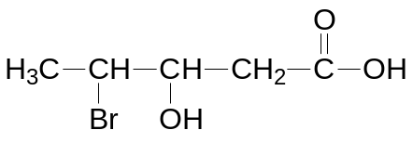  R undergoes reaction with acidified potassium manganate (VII) to give S, C₃H₄O₄, and compound T. 1 mole of S liberates 2 moles of CO₂ on reaction with excess sodium carbonate.  Deduce the structure of compounds P, Q, R, S and T, explaining the chemistry of the reactions described.  [9]
 |  |  | [Total: 20]

